# Overview

Here is the Python web application deployment procedure using Jenkins,

1. Prepare server
   1. Install python

~# python --version

~# pip --version

* 1. Create virtual environment

1. Install jenkins
2. Install necessary plugin
   1. Git
3. Deploy a Python application
   1. Download a source code from git
   2. Provide python deployment code at the “shell command” section

#!/bin/bash

virtualenv -p python3 myenv

source myenv/bin/activate

pip3 install -r requirements.txt

cd reports

touch *.xml

touch *.report

cd ..

python3 manage.py jenkins – enable-coverage

* 1. Send an email confirmation (if needed)
  2. Add a scheduler/cron job (if needed)

1. Testing
2. Monitoring

# build when a change is pushed to gitlab

1. Install “Gitlab Plugin for Jenkins”
2. go to your Gitlab repository, go to the "Integrations" section of the repo settings

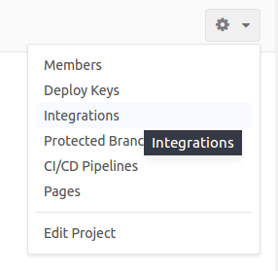

1. Then, set the webhook URL as : https://<jenkins-host>:<port>/project/<your job>

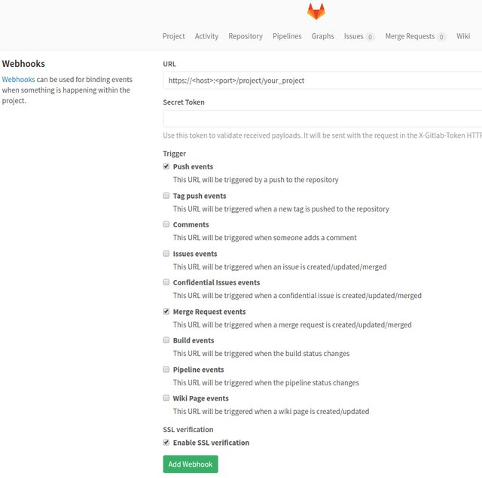

1. This way Gitlab will perform a POST request on your Jenkins Job each time the selected trigger will occur which will trigger your job task if you have configured the specified event to trigger the build.

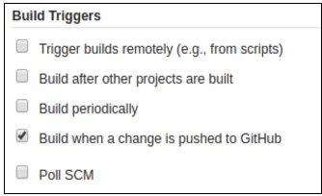

# Reference

<https://www.stratoscale.com/blog/devops/using-jenkins-build-deploy-python-web-applications-part-2/>

<https://vahiwe.medium.com/build-a-django-ci-cd-pipeline-using-jenkins-e90cbe098970>